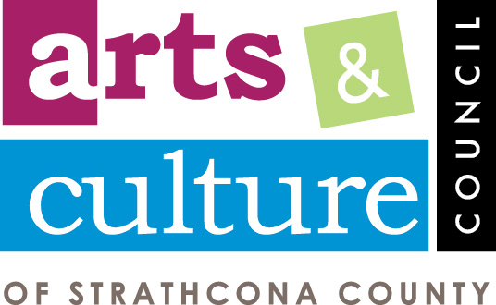
ART FOSTER PROGRAM

Thank you for applying to the Art Foster program, which is open to all visual and sculptural artists. To get started, we will need some information for our Business Partners (Fosters). Please complete the following form and submit in a .jpeg format 4 photos (including the price point of each work) from the collection you are submitting for consideration. If you don’t have an answer to the following, please put NA. This information will be given to interested Fosters along with photos of your work.

Name
Phone Number
Email Address
Town/City

Bio:

Medium |  | Website
Facebook |  | Instagram

Once a Foster has expressed interest in your collection, we’ll arrange a meeting between you and the Foster at their business location. The agreement below will be signed by the 2 parties to ensure the safety of your artwork and to set the date to hang and the date for removal. Artists are responsible for making their own tags for their artwork that encourages guests at the Foster’s business to purchase the artwork. The Foster is not responsible for selling your artwork. Participation in this program does not guarantee sales. The Art Foster Program is a marketing opportunity that showcases local artists’ talent in local businesses.

Thank you for participating in this new program and we are excited to have you join us! If you have any suggestions for the Art Foster Program, we would like to hear it!

The Arts & Culture Council of Strathcona County is proudly sponsored by

